1. Overview of Progress
The project is based on an already existing open-source library which came as a starting point to AI-based trading. The original implementation was however more research based and could not be directly applied to the project requirements. Consequently, the system underwent a massive redesign to suit the desired workflow, usability objectives and platform limitations.

The changes were not only simplification, but included reorganization of essential elements, redefining processes, and incorporating new features. This involved customizing data processing to work with local data, optimizing the backtesting pipeline to run better, building a modular graphical user interface and both manual and automated trading modules connected to the Exness broker through MetaTrader 5.

The system has now been able to support all end-to-end pipeline needed in this project, such as processing data, preparing features, training models, backtesting and interacting in real-time via GUI. The platform is mostly fully developed in terms of structure and functionality at its present stage, with the remaining work concentrated on validation, live testing, and the additional improvement of the trading performance.

2. Refactoring and Preparation of the System.
One of the significant portions of the work done in this stage was refactoring and simplifying the original codebase. The initial repository had wider prototype ideas and components which were not required by the current goals of the project. The parts that were unnecessary or were out of scope were eliminated or given low priority to make the system easier to understand, maintain, and demonstrate. This entailed a decrease in dependency on outdated demo-based workflows, a reduction in the execution paths, and a transformation of the project into a local product-oriented but not a large-scale experimental platform.

The system was also modified to suit the particular requirements of the project. Rather than relying on live scraping or a variety of data acquisition strategies, the present workflow relies on a local MetaTrader-style CSV dataset as the primary source of historical data. This increases the reproducibility, testability and academic testability of the project. On the broker side, the project was reduced to one broker route, Exness, via a local MetaTrader 5 terminal. This eliminated the complexity of having to support a number of brokers and enabled development time to go into a cleaner integration.

3. Implementation of Core Functional Modules.

3.1 Data Handling
The system can now take in local dataset with MetaTrader style of OHLCV CSV files. The project provides historical gold market data, which are imported into the dataset directory of the project and are then normalized into a standard internal format and validated and finally stored in a local SQLite database to be reused. The imported data also contains the major time-series values that are required in trading research, including open, high, low, close, and volume.

After import, the data is passed into the feature engineering pipeline. This module produces a broad set of derived features on the raw price series that are technical indicators, statistical features, time-based features, and lagged values. Target generation to support supervised learning and feature selection to support the identification of the most useful predictors to train the model are also supported by the feature preparation stage.

3.2 Model Training
The project consists of a full model training pipeline that is based on the current machine learning architecture in the repository but modified to the new workflow that is focused. The implementation does not require deriving the entire training system afresh but instead utilizes the initial modeling background and incorporates it into the streamlined project framework.

Training follows data importing and preparation of features. The system focuses on ensemble-style workflows with many machine learning models with the ability to save trained models to disk and load them again later and reuse across sessions. This is significant to both efficiency and usability as they do not need to retrain every time the application is opened. The GUI can be used to start training, and the CLI can be used as an additional interface.

3.3 Backtesting System
The system includes a backtesting module for evaluating the trained models on historical market data. After the dataset is imported and features are prepared, the backtester simulates trades over the historical period using the model’s predictions and the configured trading rules. This allows the project to measure how the strategy would have performed without using live trading.
The backtesting module produces performance metrics such as the total number of trades, win rate, total profit and loss, maximum drawdown, Sharpe ratio, Sortino ratio, and Calmar ratio. It also generates supporting outputs including the equity curve, trade summaries, JSON result files, chart images, and CSV exports. These outputs help assess the strategy’s behavior and provide a clear basis for comparing results during testing.

3.4 Broker Integration
Broker integration is available on the platform aiming at Exness using MetaTrader 5. The broker module deals with the establishment of connections, accessing the account, market data and the inspection of open positions, the placement of orders and closing of positions.

The integration of brokers is implemented by profiles and safe local secret management. Configuration holds profile metadata and passwords are transferred into a local secret store instead of being stored in tracked configuration files.

4. Graphical User Interface (GUI)

4.1 Architecture
A new GUI-first architecture implemented with Streamlit is used in the project. The graphical interface is structured in a modular page-based structure with each page being written in a separate Python file. This enhances maintainability and simplifies the process of developing or modifying certain aspects of the interface.

The separation of backend logic and user interface code is an important architectural choice. The GUI does not re-execute the system logic per se. Rather, it shares the common backend service layer with the CLI. This lessens duplication, makes the business logic centralized and ensures that research, backtesting, and broker management and trading functions act in a consistent manner across interfaces.

4.2 Implemented Pages
A number of pages have already been incorporated in the GUI.

The Dashboard gives a summary of the state of the system. It summarizes broker connection status, account metrics, open positions, auto trader state, model availability, imported dataset status and recent backtest results.
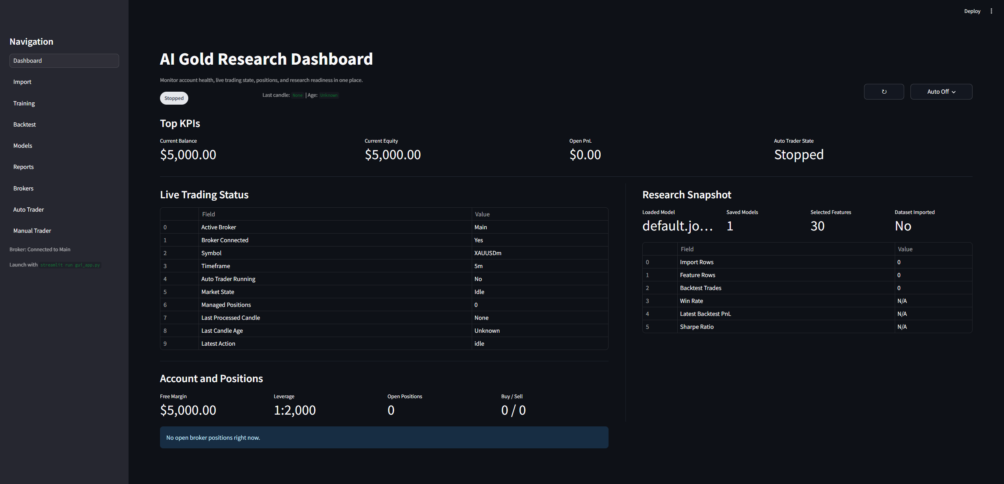
Figure 1: Dashboard

Data Import page assists in loading and preparing the local historical dataset. It is a starting point of the research process and enables the user to prepare the data required to feature engineer and to train a model.
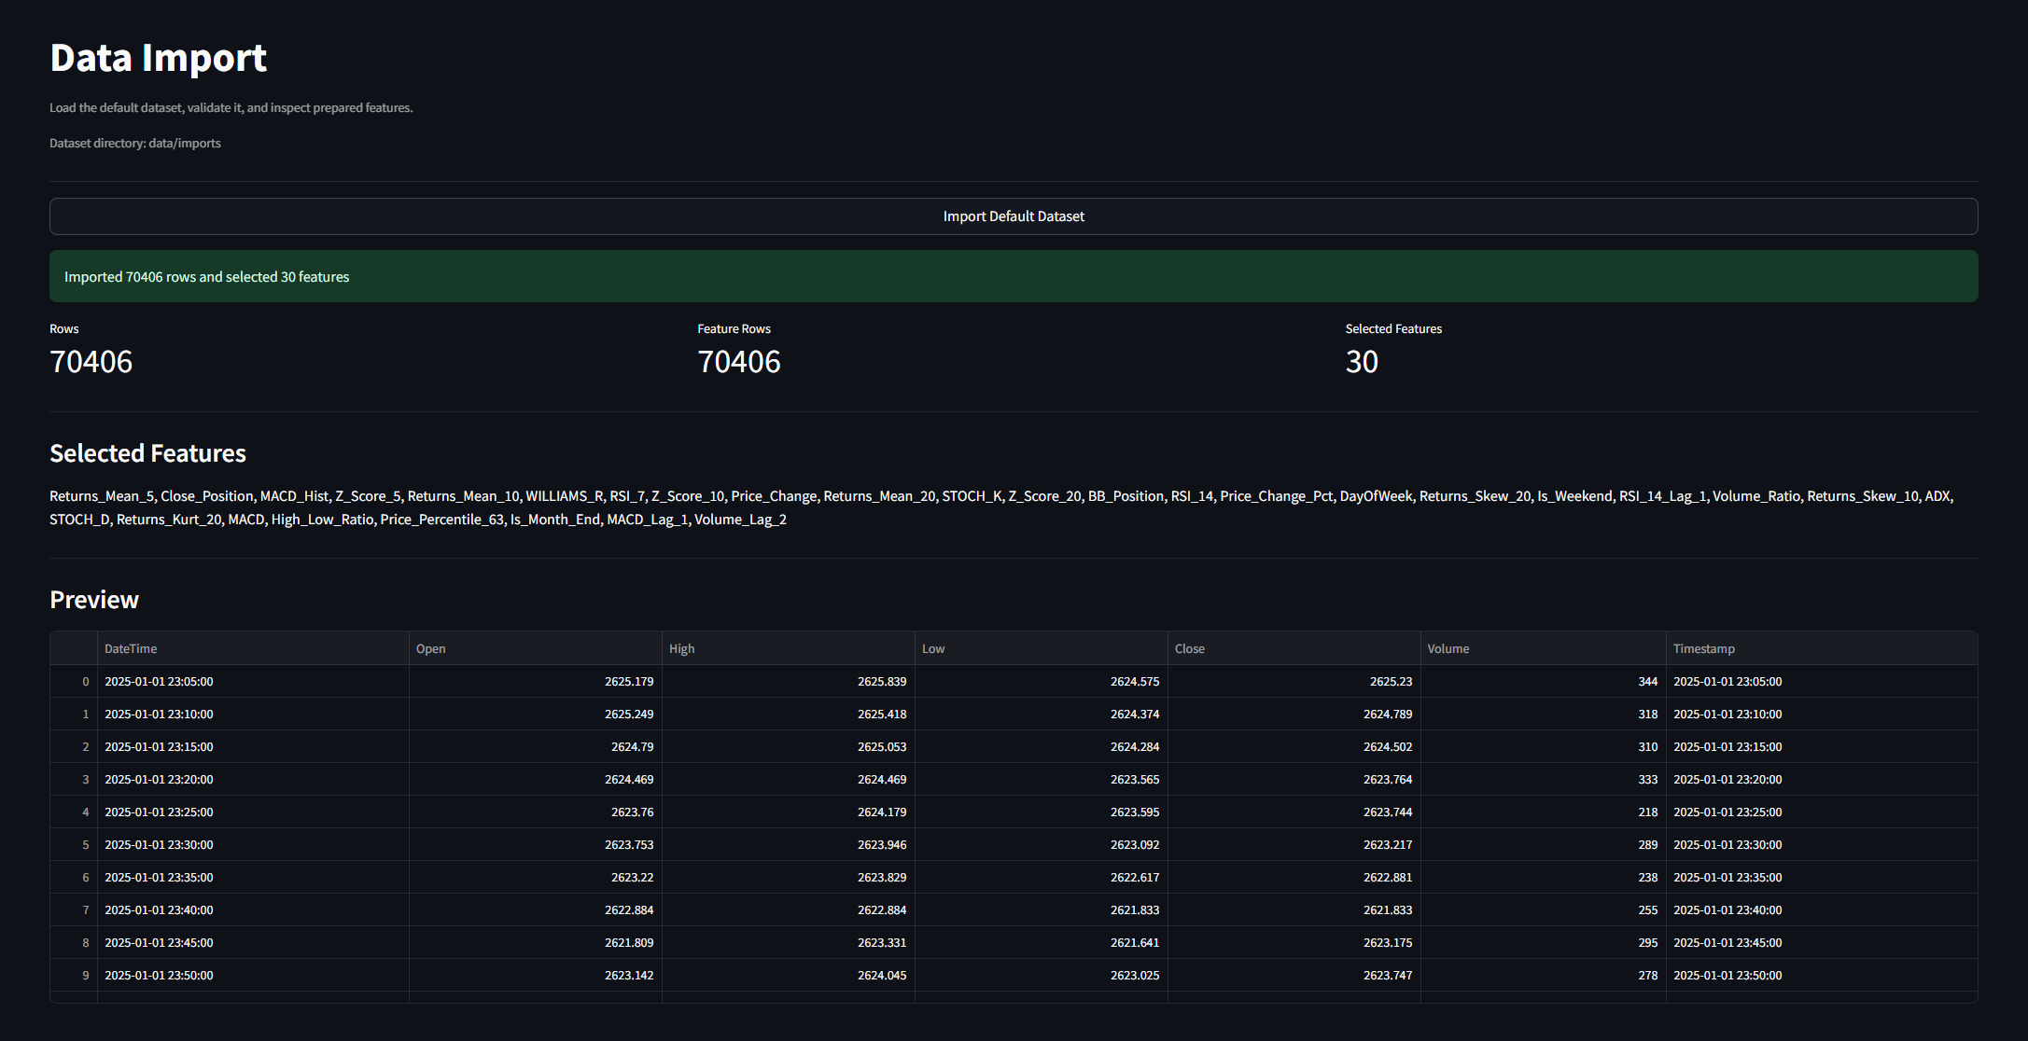
Figure 2: Data Import
The Training page enables the user to train machine learning models and store them to be used later. Backtesting page facilitates the execution of historical simulations and the examination of results. Other pages enable the user to view models saved and generated reports.
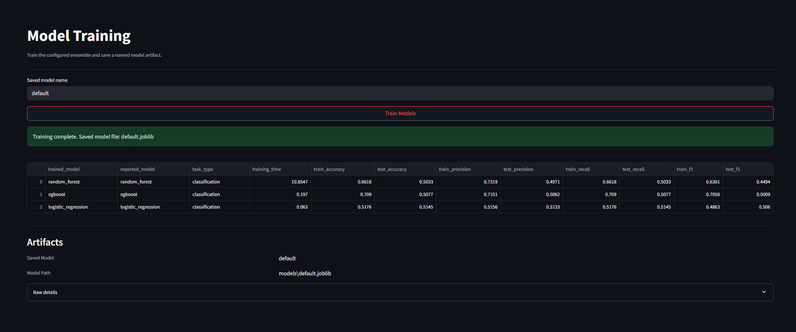
Figure 3: Model Training

The Brokers page manages and processes Exness broker profile and connection activities.
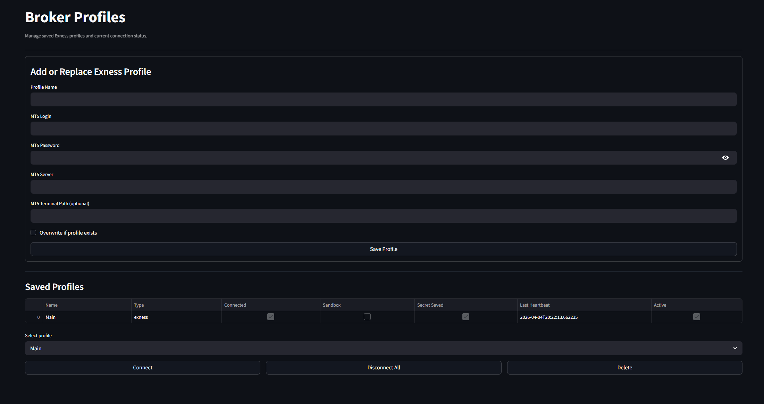
Figure 4: Broker Profiles

Manual Trading page was introduced to experiment direct broker interaction in a controlled manner. It has a price chart, order controls, the choice of the lot size, position inspection, and estimates of margin. This page is an effective interface to and validate broker communication and manual execution behavior.
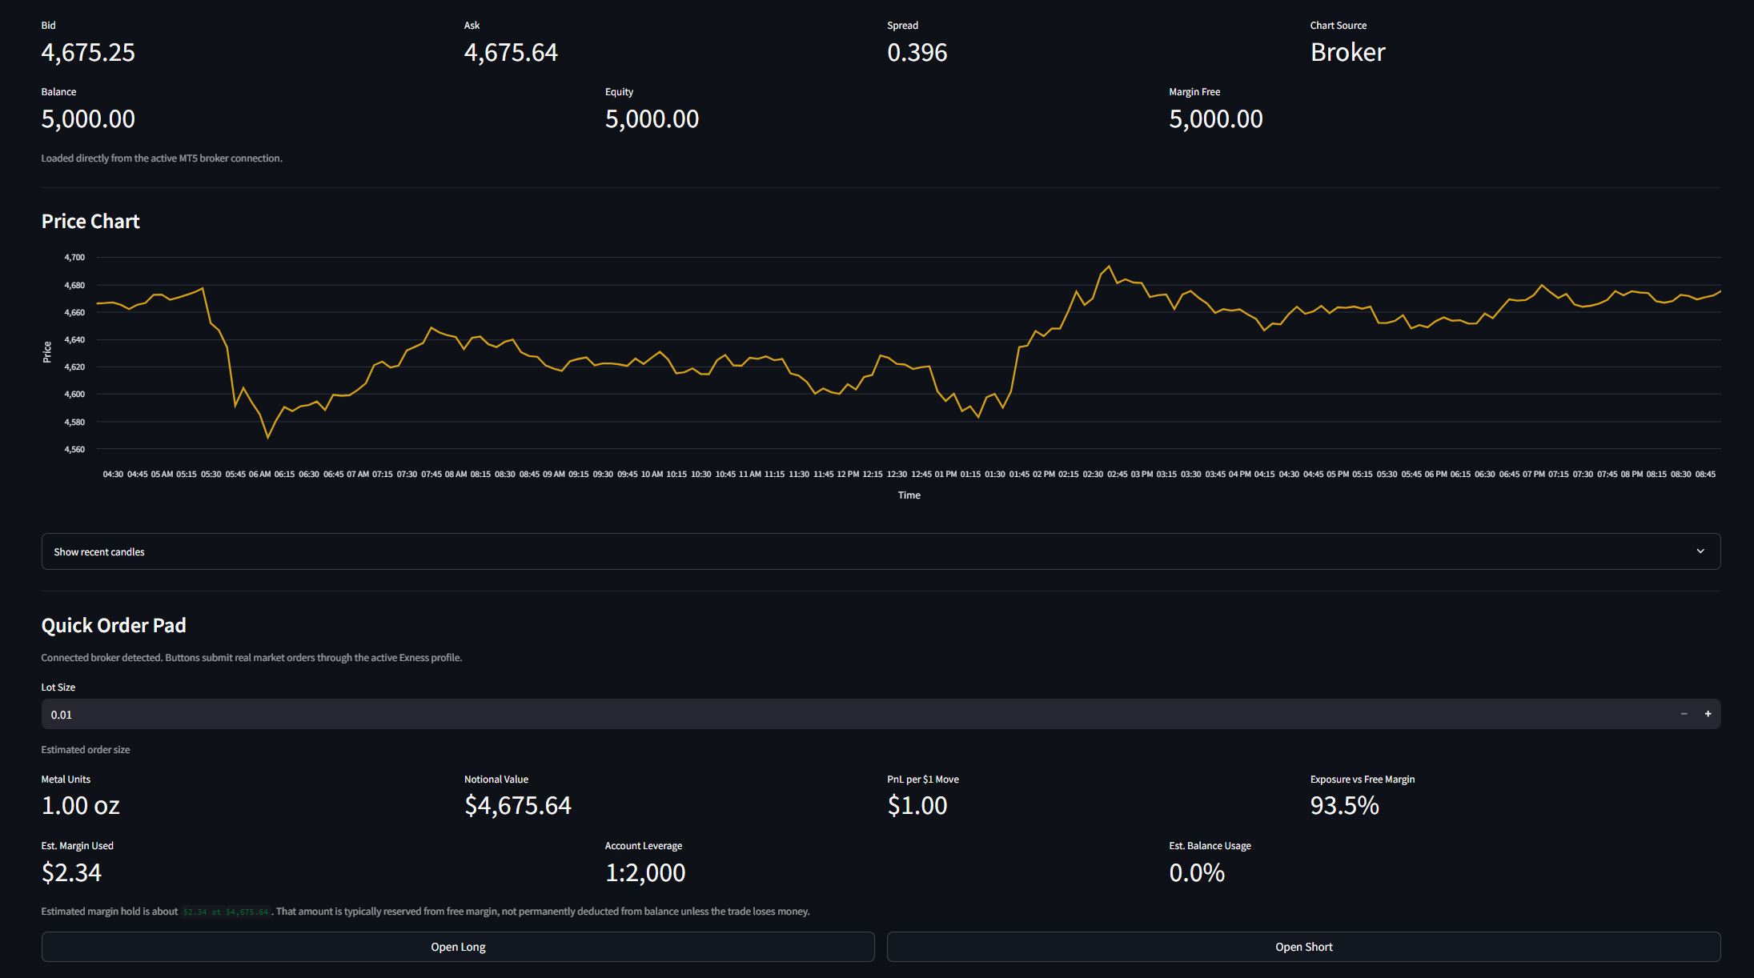
Figure 5: Manual Trading
Automated strategy execution is carried out on the Auto Trading page. It enables the user to enable or disable the auto trader, look at runtime status, look at recent events, look at positions being managed and review chart snapshots. It is based on closed-candle decision making and stale-market handling logic.
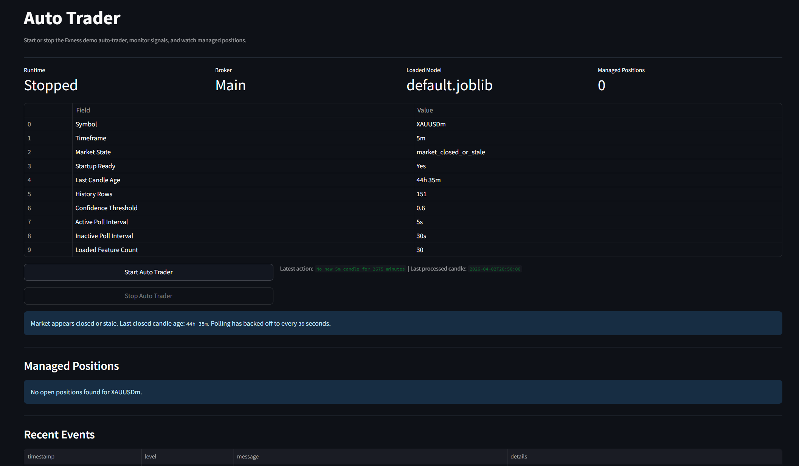
Figure 6: Auto Trader

5. System Integration
The main modules of the project have been incorporated into the single workflow. The import of data, feature preparation, model training, backtesting, broker management, dashboarding, and trading have ceased to be independent entities. They are linked with a common application service layer which coordinates the entire lifecycle of the system.

The integration enables the user to transition between local data preparation and trained model use, backtesting, and ultimately to broker-linked trading workflows in a single application. The service layer can also facilitate session-based continuity by automatically loading saved models, loading saved broker profiles, reconnecting where possible, and gathering status information to be used in the dashboard.

The dashboard snapshot system is another useful feature of the integration. It collects significant data throughout the application including broker state, open positions, imported dataset summary, number of features selected, most recent backtest performance, and auto trader runtime state. This provides a user with a centralized overview of the system without having to open each page individually.

6. Platform Readiness
The platform is currently functionally near end-to-end research and controlled demo trading workflow readiness at the current midpoint. A user is able to import a historical dataset, create features, train a model, save and reload it, backtest, view results, connect to a saved Exness profile, trade manually, and start the demo-oriented auto trader.

Besides crude functionality, usability and stability work has been done. The modular GUI enhances the non-technical usability of the interface, the shared service architecture enhances uniformity, and the system has error recovery, status reporting, logging and controlled startup scripts. These enhancements make the site more user-friendly and visual.

Security considerations were also done at a fundamental yet significant level. Only sensitive passwords of brokers are not stored in the tracked project configuration. Rather than that, they are stored in a distinct local secret store, and the tracked configuration stores profile metadata only.

7. Results
Several tests were conducted using the developed system. The following results were obtained from the backtesting module using a model trained on gold price data from 2025 to the present, consisting of approximately 70,000 entries with a 5-minute timeframe.
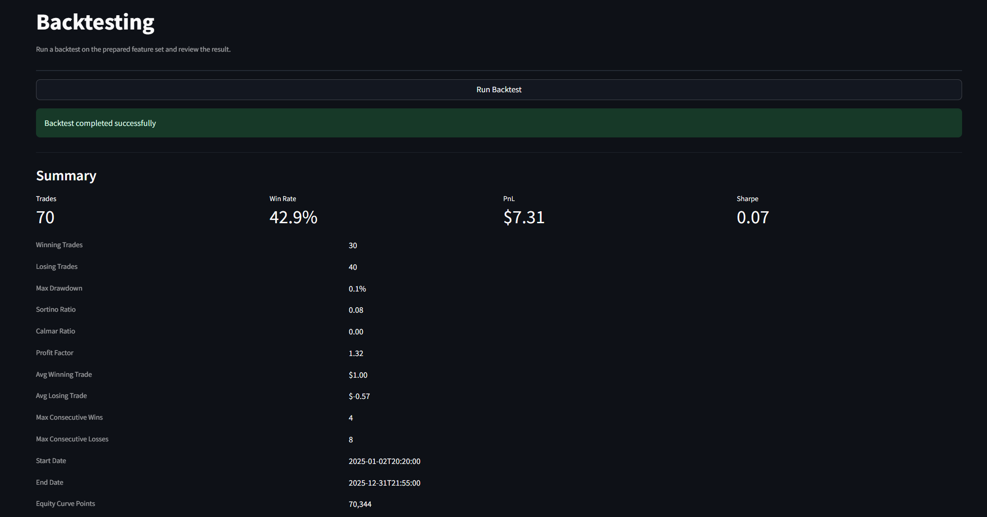
Figure 7: Backtesting

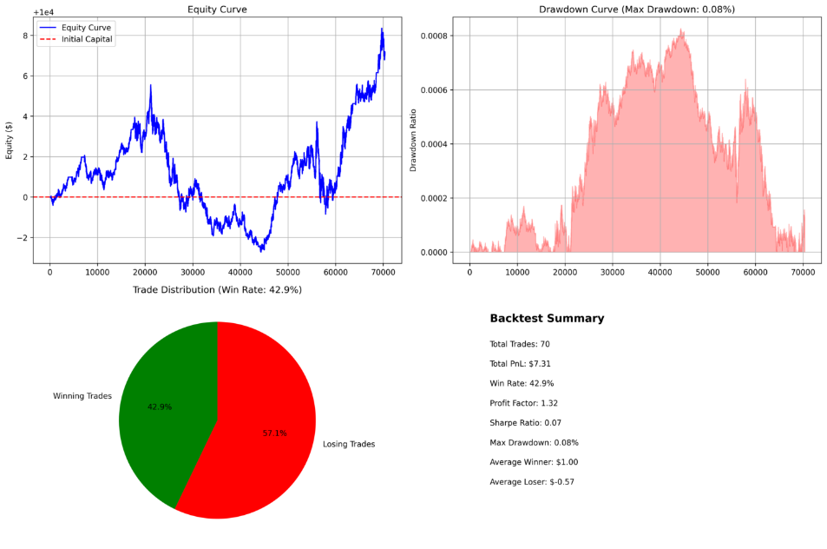
Figure 8: Results Summary

7. Summary of Progress

To conclude, the project has moved towards a wider prototype basis to a more specific and far more lucid AI gold research and trading platform. The workflow is aligned with project requirements and core modules that handle data and prepare features, train models, backtest, integrate brokers, and interact with GUI are implemented and integrated successfully.

The existing system can already sustain the principal project presentation objectives. Majority of the implementation work has been done and the next stage involves more validation and refining and further improvements in specific areas in the future rather than the construction of missing foundations.

